**Acids, Bases and Indicators**

An **acid** may be defined as a substance that turns litmus red.  
A **base** may be defined as a substance that turns litmus blue.  
An **indicator** is a substance that shows whether another substance is a base/alkaline,acid or neutral

**Acids**

There are some common and naturally occurring acids as shown in the table below

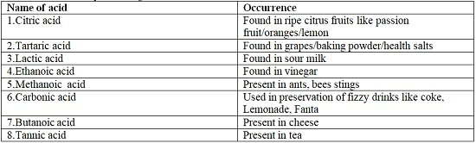

However, acids commonly used and found in a school laboratory are not naturally occurring  
They are mineral acids as illustrated below

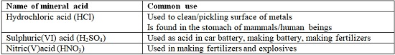

Mineral acids are manufactured to very high concentration.  
They are **corrosive** (causes painful wounds on contact with the skin) and attack/reacts with garments/clothes/metals.  
In a school laboratory, they are mainly used when added a lot of water.  
This is called diluting. Diluting ensures the concentration of the acid is safely low.

**Bases**

Bases are opposite of acids.  
Most bases do not dissolve in water.  
Bases which dissolve in water are called **alkalis.**  
Some common alkalis and their uses include;

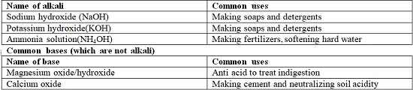

**Indicators**

An acid-base indicator is a substance used to identify whether another substance is alkaline or acidic.  
An acid-base indicator works by changing to different colors in neutral, acidic and alkaline solutions/dissolved in water.  
In an experiment to test whether solutions are acidic or alkaline, a simple acid-base indicator made of flower extracts would return the following results;

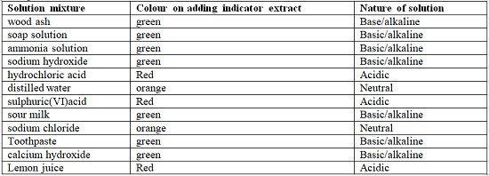

Solutions of the same nature show similar changes.  
  
Common indicators are used in school laboratories. They are cheap, readily available and easy to store. Common indicators include: **Litmus, phenolphthalein, methyl orange, screened methyl orange, bromothymol blue.**  
  
The following table shows different reults when indicators are used to test dofferent solutions

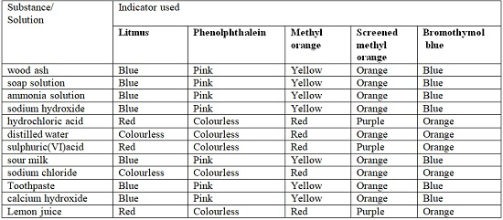

The following table shows the changes shown by indicators in different types of solution.

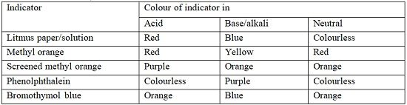

**The Universal Indicator**

Universal indicator is a mixture of other indicator dyes. The indicator uses the pH scale that shows the strength of bases and acids in a range of 1-14 as follows  
  
(i) pH values 1, 2, 3 shows a substance is a **strongly acid**  
(ii) pH values 4, 5, 6 shows a substance is a **weakly acid**  
(iii) pH value 7 shows a substance is a **neutral**  
(iv) pH values 8, 9, 10, 11 shows a substance is a **weak base/alkali.**  
(v) pH values 12, 13, 14 shows a substance is a **strong base/alkali**  
  
The universal indicator is available as: universal indicator paper/pH paper and universal indicator solution.  
  
When determining the pH of a unknown solution using **pH paper**, the pH paper is dipped into the unknown solution. It changes/turn to a certain colour. The new colour is marched/compared to its corresponding one on the pH chart to get the pH value.  
  
When determining the pH of a unknown solution using **universal indicator solution**, about 3 drops of the universal indicator solution is added into about 5cm3 of the unknown solution in a test tube. It changes/turn to a certain colour. The new colour is marched/compared to its corresponding one on the pH chart to get the pH value.

***Important notes***  
1. All the mineral acids Hydrochloric, sulphuric (VI) and nitric (V) acids are strong acids  
2. Two alkalis/soluble bases, sodium hydroxide and potassium hydroxide are strong bases/alkali. Ammonia solution is a weak base/alkali. All other bases are weakly alkaline.  
3. Pure/deionized water is a neutral solution.  
4. Common salt/sodium chloride is a neutral salt.  
5. When an acid and an alkali/base are mixed, the final product has pH 7 and is neutral.

**Properties of Acids**

**Physical Properties of Acids**

1. Acids have a characteristic sour taste  
2. Most acids are colourless liquids  
3. Mineral acids are odorless. Organic acids have characteristic smell  
4. All acids have pH less than 7  
5. All acids turn blue litmus paper red, methyl orange red and phenolphthalein colourless.  
6. All acids dissolve in water to form an acidic solution.  
7. Most do not dissolve in organic solvents like propanone, kerosene, tetrachloromethane, petrol.

**Chemical Properties of Acids**

1. All acids react with reactive metals to form a salt and produce /evolve hydrogen gas.  
**Metal + Acid ------> Salt + Hydrogen gas**  
  
The following are reactions between metals and acids

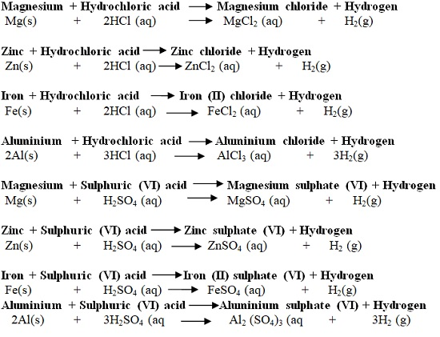

2. All acids react with carbonates and hydrogen carbonates to form salt, water and produce /evolve carbon (IV) oxide gas.  
**Metal carbonate + Acid -----> Salt + Water + Carbon(IV)oxide gas**  
**Metal hydrogen carbonate + Acid -----> Salt + Water + Carbon (IV) oxide gas**  
  
All metal carbonates/hydrogen carbonates react with dilute acids to produce bubbles of carbon (IV) oxide gas. Carbon (IV) oxide gas is a colourless gas that extinguishes a burning splint. When carbon (IV) oxide gas is bubbled in lime water, a white precipitate is formed.

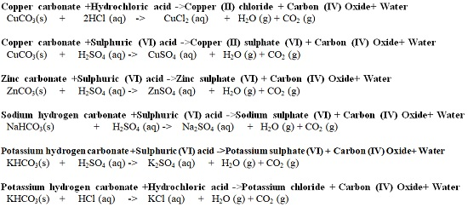

3. All acids react with bases to form a salt and water only.  
The reaction of an acid with metal oxides/hydroxides (bases) to salt and water only is called **neutralization reaction.**  
  
The reaction with alkalis requires a suitable indicator. The colour of the indicator changes when all the acid has reacted with the soluble solution of the alkali  
  
The following are reactions between acids and bases